Comparison of Low-Point and
Win-%-Ranking Scoring Methods

  - Tom Compton
March 2, 2016

I compared the results from the PRSA ILCA Fleet 50 Championship Series April 2015 – November 2015 as a demonstration of the difference between the two methods of scoring.
The customary method of scoring a series of sailboat races uses a low-point scoring system. This often results in a competitor ranking that is heavily dependent on attendance. See the Racing Rules of Sailing for Low-Point scoring details.
The Win-%-Ranking method ranks competitors based on the relative sailing performance while allowing competitors to miss a significant number of races. There is an online Win-%-Ranking calculator.

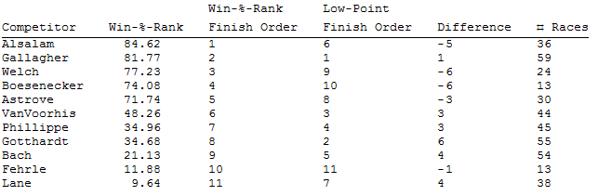
Table 1, Comparison of Low-Point Scoring Method with Win-%-Ranking method based on PRSA’s ILCA Fleet 50 Championship Series April 2015 – November 2015.

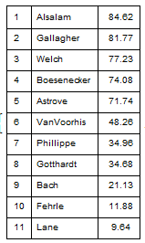
Table 2, Competitors ranked by Win-%-Ranking scoring method.
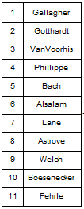
Table 3, Competitors ranked by Low-Point scoring method.

As one can see from the tables above, there are significant differences in placings between scoring methods and significant differences between number of races sailed by each competitor. These differences in number of races sailed are typical of participation in a series.
The Competitor-Pair Sign-Rank Grid, Table 12, produced as part of the Win-%-Ranking scoring method, shows the details of the competition between the pair. The table represents the outcome of each race in which the competitor-pair competed, a 1 is a win, a -1 is a loss. The rankSign is the probability based on the results for the pair that the first competitor in the pair is likely to be better than the other.
Based on looking at the details of the results, are the Win-%-Rankings reasonable?
If we look at the portion of the table that pertains to competitor Alsalam, Table 4 below,
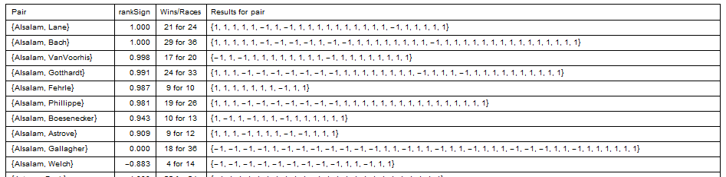
Table 4, Portion of Table 12 That Pertains to Competitor Alsalam.
we see that Alsalam won 21 of 24 races against Lane. The rankSign says that it is virtually certain that Alsalam is better than Lane. Alsalam and Gallagher are 18 for 36 in races between them. There is no statistical reason to believe one is better than another. Alsalam won 4 of 14 against Welch. The rankSign test says that there is a high probability that Welch is better than Alsalam. The Low-Point scoring system ranks Alsalam as 6th of 11 competitors. The data in Table 4 for Alsalam show only Welch and Gallagher as being competitive. It seems reasonable the Alsalam should be at the top of the rankings.
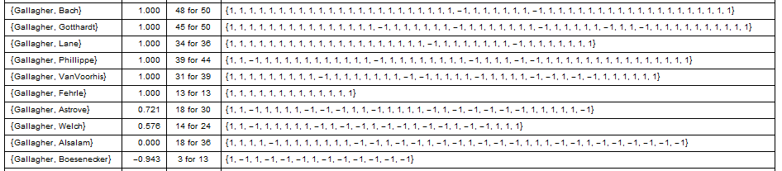
Table 5, Portion of Table 12 that Pertains to Competitor Gallagher.
Gallagher’s results are shown in Table 5. It’s not certain that Gallagher is better than Astrove or Welch. And Boesenecker is better than Gallagher. It seems reasonable that Gallagher should be at the top of the rankings.
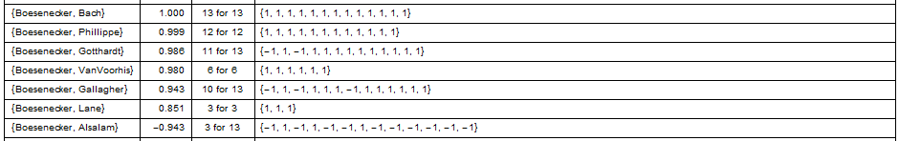
Table 6, Portion of Table 12 that Pertains to Competitor Boesenecker.
Boesenecker’s results are shown in Table 6. Boesenecker had a strong showing against other competitors, all except Alsalam. But only sailed against 7 of possible 10 other competitors. This limited the score. Beating a greater number of competitors improves one’s score. It seems reasonable that Boesenecker should be at the top of the rankings, not at the bottom as scored by Low-Point.
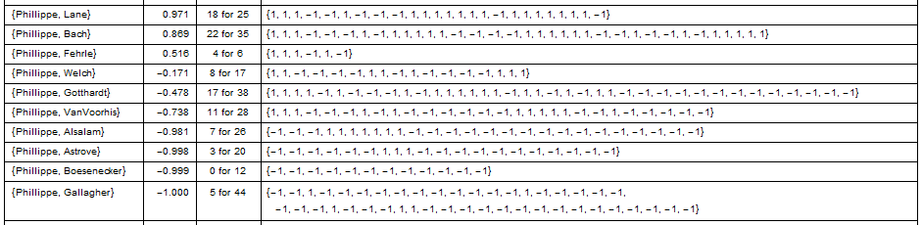
Table 7, Portion of Table 12 that Pertains to Competitor Phillippe.
The rankSign probabilities for Phillippe, show in Table 7, show some competitors likely to be better and some worse and some close. He sailed against all competitors. It would seem reasonable that Phillippe would be in the middle of the rankings.

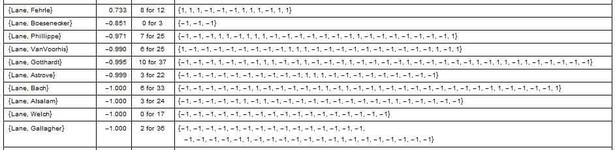
Table 8, Portion of Table 12 that Pertains to Competitor Lane.
Table 8, Win-%-Ranking data for Lane, shows that Lane is likely to be better than only one other competitor, Fehrle. The Low-Point method scored Lane 7th of 11 competitors. It seems reasonable that Lane should be at the bottom of the rankings.

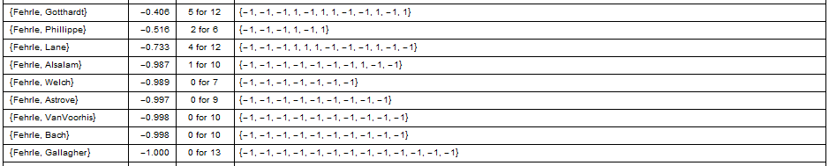
Table 9, Portion of Table 12 that Pertains to Competitor Fehrle.
The rankSign probabilities for Fehrle show Fehrle likely to score lower than all other competitors including Lane. However, due to sailing fewer races than Lane, there are larger uncertainties (lower absolute values) in Fehrle’s rankSign values. Less certainty tends to place one in the middle of the rankings. Hence Fehrle is placed higher than Lane. As more races are sailed, certainty becomes greater. It can become certain that one is good or certain that one is not. Minimum participation requirements insure that placements are reasonable. It seems reasonable the Fehrle should be in the bottom of the rankings.

Participation

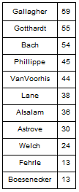
Table 10, Competitors by Number of Races Sailed, of a total of 65 races.
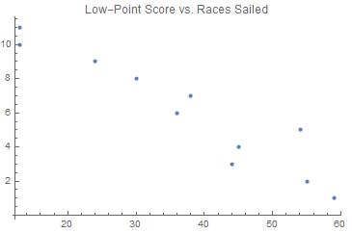
Figure 1, Plot of Low-Point Score vs. Races Sailed.
The statistical Correlation between Low-Point score and number of races sailed is -.945.

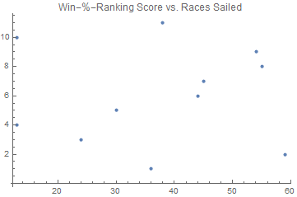
Figure 2, Plot of Win-%-Ranking Score vs. Races Sailed.
The statistical Correlation between Win-%-Ranking score and number of races sailed is -0.028.

Conclusion

The Win-%-Ranking method scores competitors in a racing series fairly based on the competitiveness of the sailors. It gets the “right answer” even when sailors can’t attend all the races.
Low-Point scoring favors attendance. I don’t think it’s right to say a good sailor is mediocre because the sailor’s attendance is low. It’s discouraging and dishonest.

Output from Win-%-Ranking Scoring Method

Table 11, Results for each race. Data extracted from Low-Point scoring results.
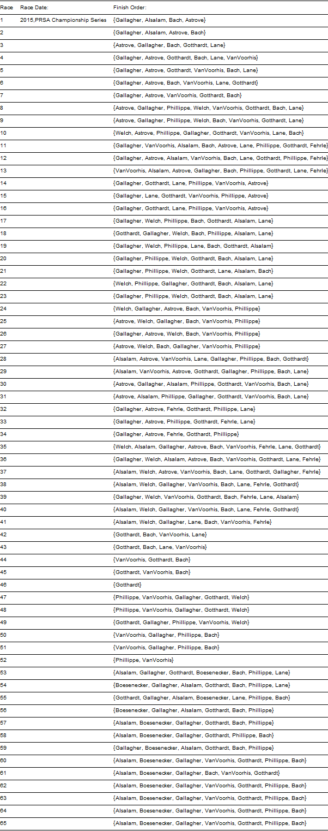
Table 12, Competitor-Pair Sign-Rank Grid Produced by Win-%-Ranking Scoring Method.
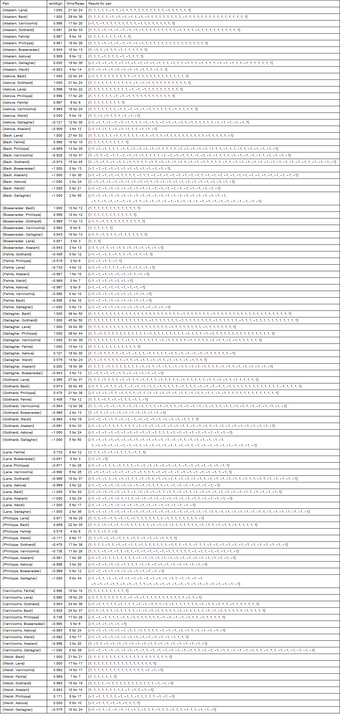
Table 13, Competitors meeting minimum participation requirements.
